Occupation Overview
Emsi Q3 2017 Data Set
October 2017
Bakersfield College
1801 Panorama Drive
Bakersfield, California 93305
661.395.4921
Parameters
Occupations
12 items selected. See Appendix A for details.
Regions
Code | Description
12540 | Bakersfield, CA

Timeframe
2014 - 2023
Datarun
2017.3 – Employees
12 Occupations in Bakersfield Area
Occupation Summary for 12 Occupations
5,543 | 5.0% | $24.37/hr
Jobs (2016) | % Change (2014-2023) | Median Hourly Earnings
4% above National average | Nation: 11.8% | Nation: $20.35/hr

Growth
5,769 | 6,055 | 286 | 5.0%
2014 Jobs | 2023 Jobs | Change (2014-2023) | % Change (2014-2023)

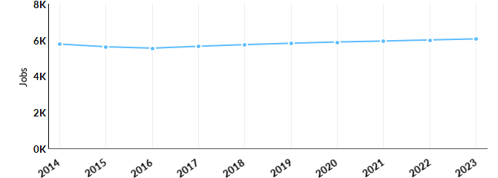
Occupation | 2014 Jobs | 2023 Jobs | Change | % Change
Electrical and Electronics Engineering Technicians (17-3023) | 728 | 705 | -23 | -3%
Electro-Mechanical Technicians (17-3024) | 49 | 39 | -10 | -20%
Sales Engineers (41-9031) | 118 | 108 | -10 | -8%
Electric Motor, Power Tool, and Related Repairers (49-2092) | 39 | 31 | -8 | -21%
Electrical and Electronics Repairers, Commercial and Industrial Equipment (49-2094) | 176 | 172 | -4 | -2%
Electrical and Electronics Repairers, Powerhouse, Substation, and Relay (49-2095) | 24 | 19 | -5 | -21%
Control and Valve Installers and Repairers, Except Mechanical Door (49-9012) | 76 | 62 | -14 | -18%
Industrial Machinery Mechanics (49-9041) | 1,106 | 1,143 | 37 | 3%
Maintenance Workers, Machinery (49-9043) | 253 | 265 | 12 | 5%
Precision Instrument and Equipment Repairers, All Other (49-9069) | 11 | 11 | 0 | 0%
Maintenance and Repair Workers, General (49-9071) | 2,853 | 3,145 | 292 | 10%
Installation, Maintenance, and Repair Workers, All Other (49-9099) | 336 | 354 | 18 | 5%

Percentile Earnings
$17.44/hr | $24.25/hr | $31.57/hr
25th Percentile Earnings | Median Earnings | 75th Percentile Earnings
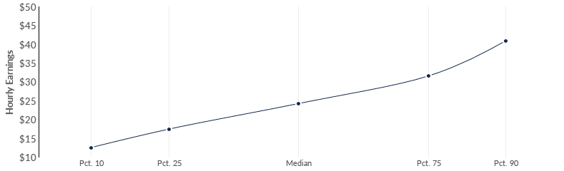
Occupation | 25th Percentile Earnings | Median Earnings | 75th Percentile Earnings
Electrical and Electronics Engineering Technicians (17-3023) | $31.96 | $38.52 | $46.90
Electro-Mechanical Technicians (17-3024) | $28.37 | $33.97 | $40.50
Sales Engineers (41-9031) | $35.75 | $53.03 | $70.04
Electric Motor, Power Tool, and Related Repairers (49-2092) | $19.94 | $25.54 | $36.29
Electrical and Electronics Repairers, Commercial and Industrial Equipment (49-2094) | $27.12 | $31.38 | $34.35
Electrical and Electronics Repairers, Powerhouse, Substation, and Relay (49-2095) | $37.84 | $44.10 | $50.70
Control and Valve Installers and Repairers, Except Mechanical Door (49-9012) | $15.16 | $33.67 | $42.65
Industrial Machinery Mechanics (49-9041) | $23.67 | $29.01 | $35.93
Maintenance Workers, Machinery (49-9043) | $19.12 | $23.46 | $28.04
Precision Instrument and Equipment Repairers, All Other (49-9069) | $27.19 | $33.64 | $41.20
Maintenance and Repair Workers, General (49-9071) | $14.89 | $19.66 | $25.89
Installation, Maintenance, and Repair Workers, All Other (49-9099) | $13.35 | $16.31 | $20.40

Regional Trends
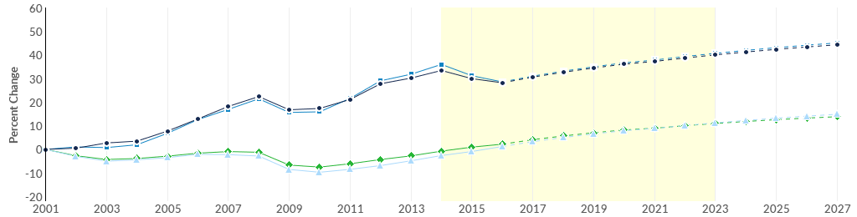
 | Region | 2014 Jobs | 2023 Jobs | Change | % Change
● | Region | 5,769 | 6,055 | 286 | 5.0%
● | BC Service Area DEMOGRAPHIC | 4,093 | 4,235 | 142 | 3.5%
● | California | 235,728 | 269,292 | 33,564 | 14.2%
● | United States | 2,363,848 | 2,643,450 | 279,602 | 11.8%

Regional Breakdown
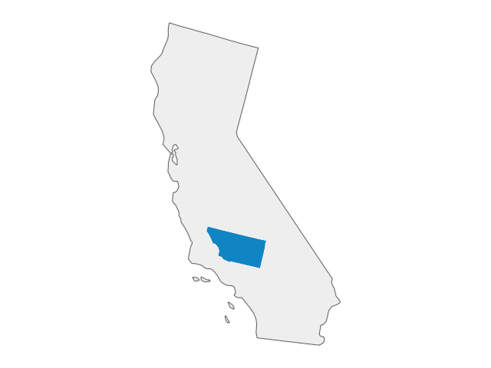

County | 2023 Jobs
Kern County, CA | 6,055

Job Postings Summary
9,718 | 5 : 1
Unique Postings (Jan 2014 - Sep 2017) | Posting Intensity (Jan 2014 - Sep 2017)
45,732 Total Postings | Regional Average: 6 : 1
There were 45,732 total job postings for your selection from January 2014 to September 2017, of which 9,718 were unique. These numbers give us a Posting Intensity of 5-to-1, meaning that for every 5 postings there is 1 unique job posting.This is lower than the Posting Intensity for all other occupations and companies in the region (6-to-1), indicating that they may not be trying as hard to hire for this position.
Job Postings vs. Hires
216 | 297
Avg. Monthly Postings (Jan 2014 - Sep 2017) | Avg. Monthly Hires (Jan 2014 - Sep 2017)
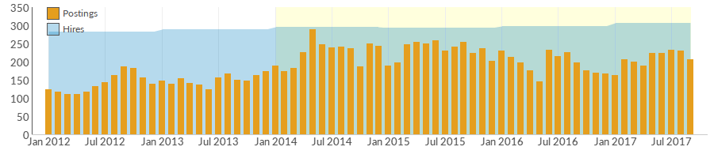
Occupation | Avg Monthly Postings (Jan 2014 - Sep 2017) | Avg Monthly Hires (Jan 2014 - Sep 2017)
Maintenance and Repair Workers, General | 126 | 177
Electrical and Electronics Engineering Technicians | 47 | 23
Industrial Machinery Mechanics | 24 | 47
Sales Engineers | 7 | 3
Installation, Maintenance, and Repair Workers, All Other | 4 | 17
Electrical and Electronics Repairers, Commercial and Industrial Equipment | 3 | 6
Electro-Mechanical Technicians | 2 | 1
Maintenance Workers, Machinery | 1 | 19
Electrical and Electronics Repairers, Powerhouse, Substation, and Relay | 1 | 1
Control and Valve Installers and Repairers, Except Mechanical Door | 0 | 2
Precision Instrument and Equipment Repairers, All Other | 0 | 0
Electric Motor, Power Tool, and Related Repairers | 0 | 1

Occupation Gender Breakdown
 | Gender | 2016 Jobs | 2016 Percent
● | Males | 5,204 | 93.9%
● | Females | 338 | 6.1%

Occupation Age Breakdown
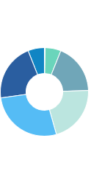
 | Age | 2016 Jobs | 2016 Percent
● | 14-18 | 16 | 0.3%
● | 19-24 | 322 | 5.8%
● | 25-34 | 1,020 | 18.4%
● | 35-44 | 1,170 | 21.1%
● | 45-54 | 1,508 | 27.2%
● | 55-64 | 1,172 | 21.1%
● | 65+ | 335 | 6.0%

Occupation Race/Ethnicity Breakdown
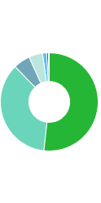
 | Race/Ethnicity | 2016 Jobs | 2016 Percent
● | White | 2,868 | 51.8%
● | Hispanic or Latino | 1,992 | 35.9%
● | Asian | 306 | 5.5%
● | Black or African American | 253 | 4.6%
● | Two or More Races | 74 | 1.3%
● | American Indian or Alaska Native | 34 | 0.6%
● | Native Hawaiian or Other Pacific Islander | 17 | 0.3%

Occupational Programs
8 |  | 121 | 584
Programs (2016) |  | Completions (2016) | Openings (2016)
CIP Code | Program |  |  | Completions (2016)
47.0101 | Electrical/Electronics Equipment Installation and Repair, General |  |  | 67
15.9999 | Engineering Technologies and Engineering-Related Fields, Other |  |  | 35
47.0104 | Computer Installation and Repair Technology/Technician |  |  | 11
46.0302 | Electrician |  |  | 8
15.0000 | Engineering Technology, General |  |  | 0

Industries Employing 12 Occupations
Industry | Occupation Group Jobs in Industry (2016) | % of Occupation Group in Industry (2016) | % of Total Jobs in Industry (2016)
Local Government, Excluding Education and Hospitals | 468 | 8.4% | 3.5%
Federal Government, Civilian, Excluding Postal Service | 323 | 5.8% | 3.5%
Commercial and Industrial Machinery and Equipment (except Automotive and Electronic) Repair and Maintenance | 212 | 3.8% | 26.5%
Crop Production | 176 | 3.2% | 1.0%
Elementary and Secondary Schools (Local Government) | 164 | 3.0% | 0.7%

Appendix A - Occupations
Code | Description
17-3023 | Electrical and Electronics Engineering Technicians
17-3024 | Electro-Mechanical Technicians
41-9031 | Sales Engineers
49-2094 | Electrical and Electronics Repairers, Commercial and Industrial Equipment
49-2095 | Electrical and Electronics Repairers, Powerhouse, Substation, and Relay
49-9012 | Control and Valve Installers and Repairers, Except Mechanical Door
49-2092 | Electric Motor, Power Tool, and Related Repairers
49-9041 | Industrial Machinery Mechanics
49-9043 | Maintenance Workers, Machinery
49-9069 | Precision Instrument and Equipment Repairers, All Other
49-9071 | Maintenance and Repair Workers, General
49-9099 | Installation, Maintenance, and Repair Workers, All Other

Appendix B - Data Sources and Calculations
Location Quotient
Location quotient (LQ) is a way of quantifying how concentrated a particular industry, cluster, occupation, or demographic group is in a region as compared to the nation. It can reveal what makes a particular region unique in comparison to the national average.
Occupation Data
Emsi occupation employment data are based on final Emsi industry data and final Emsi staffing patterns. Wage estimates are based on Occupational Employment Statistics (QCEW and Non-QCEW Employees classes of worker) and the American Community Survey (Self-Employed and Extended Proprietors). Occupational wage estimates also affected by county-level Emsi earnings by industry.
CareerBuilder/Emsi Job Postings
Job postings are collected from various sources and processed/enriched by Careerbuilder to provide information such as standardized company name, occupation, skills, and geography. Emsi performs additional filtering and processing to improve compatibility with Emsi data.
Completers Data
The completers data in this report is taken directly from the national IPEDS database published by the U.S. Department of Education's National Center for Education Statistics.
Institution Data
The institution data in this report is taken directly from the national IPEDS database published by the U.S. Department of Education's National Center for Education Statistics.
State Data Sources
This report uses state data from the following agencies: California Labor Market Information Department

