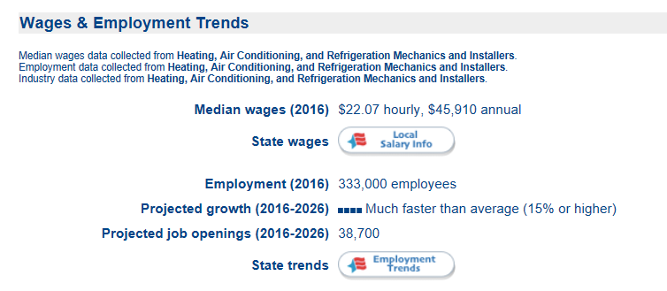

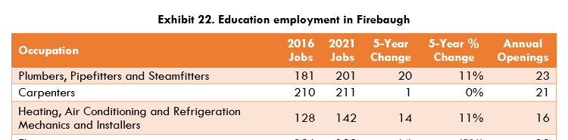

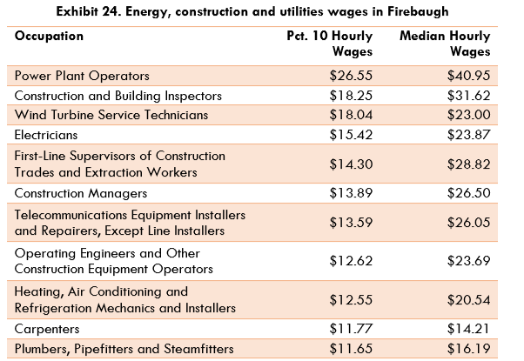



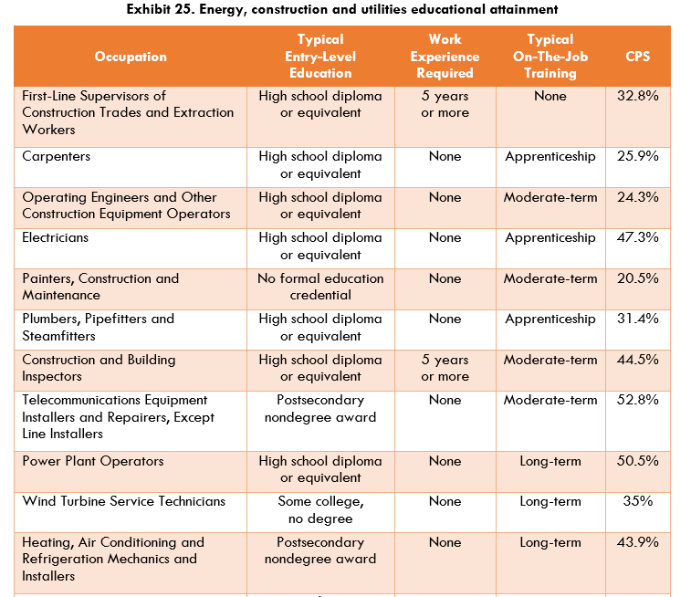



<http://coeccc.net/region/CentralCalifornia.aspx>

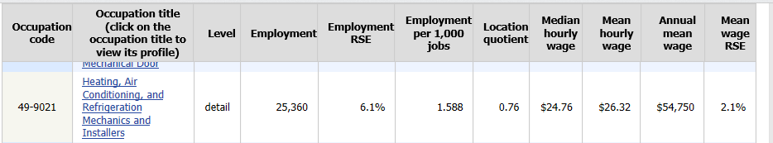

<https://www.bls.gov/oes/current/oes_ca.htm#49-0000>

**Centers of Excellence Data**



The following SOC codes were used for employment: Sheet Metal Workers (47-2211); Heating, Air Conditioning, and Refrigeration Mechanics and Installers (49-9021)

Employer Survey