Occupation Overview
Emsi Q4 2017 Data Set
December 2017
California
Parameters
Occupations
Code | Description
27-2041 | Music Directors and Composers
27-4014 | Sound Engineering Technicians
27-4011 | Audio and Video Equipment Technicians
27-2042 | Musicians and Singers
15-1132 | Software Developers, Applications

Regions
Code | Description
6019 | Fresno County, CA
6031 | Kings County, CA
6039 | Madera County, CA
6047 | Merced County, CA
6107 | Tulare County, CA

Timeframe
2017 - 2027
Datarun
2017.4 – QCEW Employees, Non-QCEW Employees, and Self-Employed
5 Occupations in 5 California Counties
Occupation Summary for 5 Occupations
1,736 |  | 16.8% |  | $25.36/hr
Jobs (2017) |  | % Change (2017-2027) |  | Median Hourly Earnings
71% below National average |  | Nation: 18.5% |  | Nation: $40.24/hr
Growth
1,736 | 2,028 |  | 292 |  | 16.8%
2017 Jobs | 2027 Jobs |  | Change (2017-2027) |  | % Change (2017-2027)
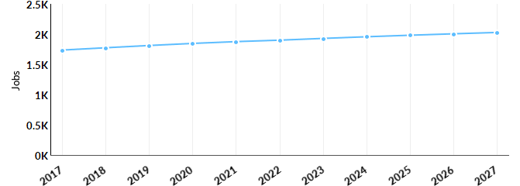
Occupation | 2017 Jobs | 2027 Jobs | Change | % Change
Software Developers, Applications (15-1132) | 579 | 760 | 181 | 31%
Music Directors and Composers (27-2041) | 261 | 283 | 22 | 8%
Musicians and Singers (27-2042) | 548 | 580 | 32 | 6%
Audio and Video Equipment Technicians (27-4011) | 301 | 353 | 52 | 17%
Sound Engineering Technicians (27-4014) | 47 | 51 | 4 | 9%

Percentile Earnings
$17.33/hr | $25.36/hr | $41.24/hr
25th Percentile Earnings | Median Earnings | 75th Percentile Earnings
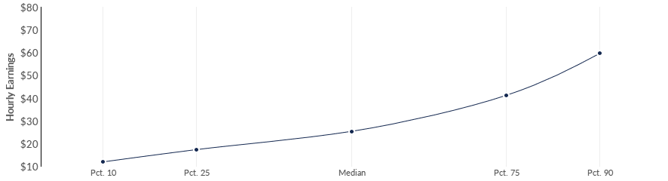
Occupation | 25th Percentile Earnings | Median Earnings | 75th Percentile Earnings
Software Developers, Applications (15-1132) | $33.71 | $44.72 | $59.47
Music Directors and Composers (27-2041) | $15.06 | $22.90 | $28.63
Musicians and Singers (27-2042) | $15.85 | $18.37 | $29.97
Audio and Video Equipment Technicians (27-4011) | $12.58 | $20.66 | $23.38
Sound Engineering Technicians (27-4014) | $10.55 | $14.15 | $27.47
Regional Trends
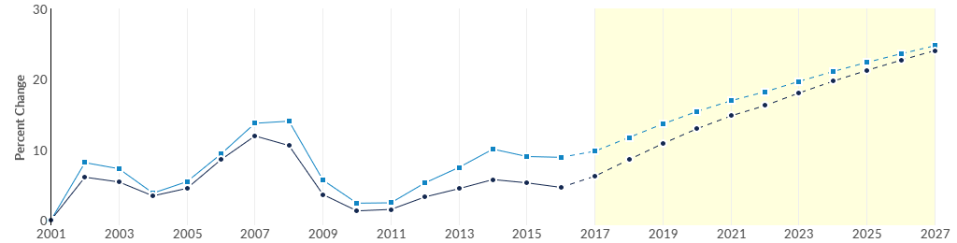
 | Region | 2017 Jobs | 2027 Jobs | Change | % Change
● | Region | 1,736 | 2,028 | 292 | 16.8%
● | Fresno, CA | 1,137 | 1,292 | 155 | 13.6%

Regional Breakdown
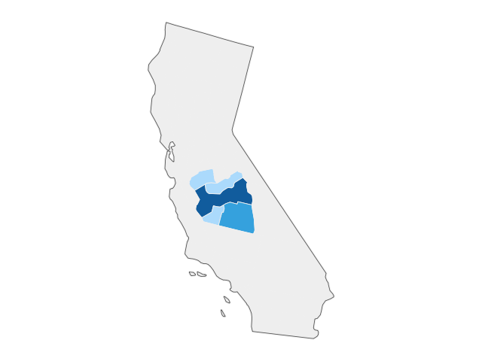

County | 2027 Jobs
Fresno County, CA | 1,292
Tulare County, CA | 358
Merced County, CA | 156
Kings County, CA | 126
Madera County, CA | 96
Job Postings Summary
423 | 4 : 1
Unique Postings (Jan 2017 - Nov 2017) | Posting Intensity (Jan 2017 - Nov 2017)
1,613 Total Postings | Regional Average: 7 : 1
There were 1,613 total job postings for your selection from January 2017 to November 2017, of which 423 were unique. These numbers give us a Posting Intensity of 4-to-1, meaning that for every 4 postings there is 1 unique job posting.This is lower than the Posting Intensity for all other occupations and companies in the region (7-to-1), indicating that they may not be trying as hard to hire for this position.
Job Postings vs. Hires
38 | 69
Avg. Monthly Postings (Jan 2017 - Nov 2017) | Avg. Monthly Hires (Jan 2017 - Nov 2017)
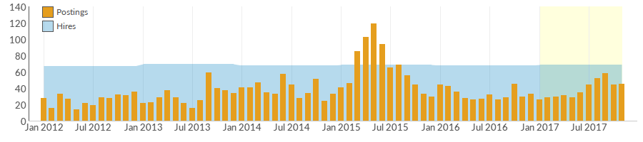
Occupation | Avg Monthly Postings (Jan 2017 - Nov 2017) | Avg Monthly Hires (Jan 2017 - Nov 2017)
Software Developers, Applications | 32 | 30
Audio and Video Equipment Technicians | 3 | 14
Musicians and Singers | 3 | 14
Sound Engineering Technicians | 0 | 2
Music Directors and Composers | 0 | 9
Occupation Gender Breakdown
 | Gender | 2017 Jobs | 2017 Percent
● | Males | 1,268 | 73.1%
● | Females | 467 | 26.9%

Occupation Age Breakdown
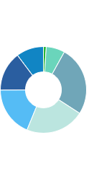
 | Age | 2017 Jobs | 2017 Percent
● | 14-18 | 18 | 1.1%
● | 19-24 | 122 | 7.0%
● | 25-34 | 452 | 26.0%
● | 35-44 | 384 | 22.1%
● | 45-54 | 325 | 18.7%
● | 55-64 | 257 | 14.8%
● | 65+ | 179 | 10.3%
Occupation Race/Ethnicity Breakdown
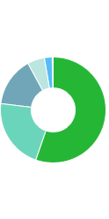
 | Race/Ethnicity |  |  |  | 2017 Jobs |  |  |  | 2017 Percent
● | White |  |  |  | 961 |  |  |  | 55.3%
● | Asian |  |  |  | 375 |  |  |  | 21.6%
● | Hispanic or Latino |  |  |  | 263 |  |  |  | 15.1%
● | Black or African American |  |  |  | 91 |  |  |  | 5.3%
● | Two or More Races |  |  |  | 41 |  |  |  | 2.4%
● | Native Hawaiian or Other Pacific Islander |  |  |  | 3 |  |  |  | 0.2%
● | American Indian or Alaska Native |  |  |  | 3 |  |  |  | 0.2%
Occupational Programs
12 |  |  | 315 |  |  | 173
Programs (2016) |  |  | Completions (2016) |  |  | Openings (2016)
CIP Code |  | Program |  |  |  |  | Completions (2016)
11.0103 |  | Information Technology |  |  |  |  | 82
14.0901 |  | Computer Engineering, General |  |  |  |  | 72
50.0901 |  | Music, General |  |  |  |  | 63
11.0701 |  | Computer Science |  |  |  |  | 62
10.0201 |  | Photographic and Film/Video Technology/Technician and Assistant |  |  |  |  | 28
Industries Employing 5 Occupations
Industry |  |  |  | Occupation Group Jobs in Industry (2017) |  |  |  | % of Occupation Group in Industry (2017) |  | % of Total Jobs in Industry (2017)
Religious Organizations |  |  |  | 497 |  |  |  | 28.6% |  | 7.5%
Independent Artists, Writers, and Performers |  |  |  | 139 |  |  |  | 8.0% |  | 23.0%
Elementary and Secondary Schools (Local Government) |  |  |  | 72 |  |  |  | 4.2% |  | 0.1%
Computer Systems Design Services |  |  |  | 53 |  |  |  | 3.1% |  | 8.5%
Custom Computer Programming Services |  |  |  | 52 |  |  |  | 3.0% |  | 8.1%

Appendix A - Data Sources and Calculations
Location Quotient
Location quotient (LQ) is a way of quantifying how concentrated a particular industry, cluster, occupation, or demographic group is in a region as compared to the nation. It can reveal what makes a particular region unique in comparison to the national average.
Occupation Data
Emsi occupation employment data are based on final Emsi industry data and final Emsi staffing patterns. Wage estimates are based on Occupational Employment Statistics (QCEW and Non-QCEW Employees classes of worker) and the American Community Survey (Self-Employed and Extended Proprietors). Occupational wage estimates also affected by county-level Emsi earnings by industry.
CareerBuilder/Emsi Job Postings
Job postings are collected from various sources and processed/enriched by Careerbuilder to provide information such as standardized company name, occupation, skills, and geography. Emsi performs additional filtering and processing to improve compatibility with Emsi data.
Institution Data
The institution data in this report is taken directly from the national IPEDS database published by the U.S. Department of Education's National Center for Education Statistics.
State Data Sources
This report uses state data from the following agencies: California Labor Market Information Department

