Occupation Overview
Emsi Q2 2018 Data Set
April 2018
California
Parameters
Occupations
Code | Description
47-2152 | Plumbers, Pipefitters, and Steamfitters
47-3015 | Helpers--Pipelayers, Plumbers, Pipefitters, and Steamfitters
49-1011 | First-Line Supervisors of Mechanics, Installers, and Repairers
49-9021 | Heating, Air Conditioning, and Refrigeration Mechanics and Installers
49-9043 | Maintenance Workers, Machinery
49-9071 | Maintenance and Repair Workers, General
49-9098 | Helpers--Installation, Maintenance, and Repair Workers
49-9099 | Installation, Maintenance, and Repair Workers, All Other

Regions
Code | Description
6019 | Fresno County, CA
6031 | Kings County, CA
6039 | Madera County, CA
6047 | Merced County, CA
6107 | Tulare County, CA

Timeframe
-
Datarun
2018.2 – QCEW Employees, Non-QCEW Employees, and Self-Employed
8 Occupations in 5 California Counties
Occupation Summary for 8 Occupations
14,539 |  | 16.5% |  | $18.92/hr
Jobs (2017) |  | % Change (2017-2027) |  | Median Hourly Earnings
11% below National average |  | Nation: 10.8% |  | Nation: $19.76/hr
Growth
14,539 | 16,933 |  | 2,394 |  | 16.5%
2017 Jobs | 2027 Jobs |  | Change (2017-2027) |  | % Change (2017-2027)
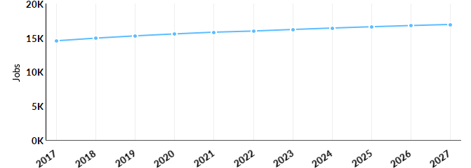
Occupation | 2017 Jobs | 2027 Jobs | Change | % Change
Plumbers, Pipefitters, and Steamfitters (47-2152) | 1,705 | 2,161 | 456 | 27%
Helpers--Pipelayers, Plumbers, Pipefitters, and Steamfitters (47-3015) | 141 | 197 | 56 | 40%
First-Line Supervisors of Mechanics, Installers, and Repairers (49-1011) | 2,016 | 2,309 | 293 | 15%
Heating, Air Conditioning, and Refrigeration Mechanics and Installers (49-9021) | 1,727 | 2,136 | 409 | 24%
Maintenance Workers, Machinery (49-9043) | 594 | 696 | 102 | 17%
Maintenance and Repair Workers, General (49-9071) | 6,843 | 7,754 | 911 | 13%
Helpers--Installation, Maintenance, and Repair Workers (49-9098) | 492 | 581 | 89 | 18%
Installation, Maintenance, and Repair Workers, All Other (49-9099) | 1,021 | 1,098 | 77 | 8%

Percentile Earnings
$14.15/hr | $18.92/hr | $26.26/hr
25th Percentile Earnings | Median Earnings | 75th Percentile Earnings
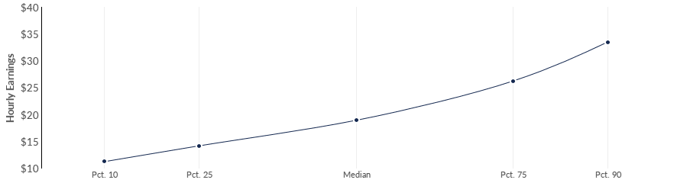
Occupation | 25th Percentile Earnings | Median Earnings | 75th Percentile Earnings
Plumbers, Pipefitters, and Steamfitters (47-2152) | $15.56 | $22.03 | $30.12
Helpers--Pipelayers, Plumbers, Pipefitters, and Steamfitters (47-3015) | $12.62 | $15.13 | $17.35
First-Line Supervisors of Mechanics, Installers, and Repairers (49-1011) | $23.28 | $30.74 | $39.22
Heating, Air Conditioning, and Refrigeration Mechanics and Installers (49-9021) | $15.07 | $19.42 | $26.90
Maintenance Workers, Machinery (49-9043) | $14.88 | $18.59 | $23.80
Maintenance and Repair Workers, General (49-9071) | $13.07 | $17.61 | $23.03
Helpers--Installation, Maintenance, and Repair Workers (49-9098) | $10.51 | $11.88 | $14.18
Installation, Maintenance, and Repair Workers, All Other (49-9099) | $12.97 | $15.47 | $19.39

Regional Trends
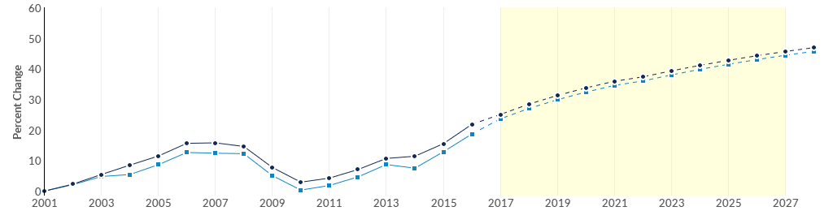
 | Region | 2017 Jobs | 2027 Jobs | Change | % Change
● | Region | 14,539 | 16,933 | 2,394 | 16.5%
● | Fresno, CA | 7,560 | 8,831 | 1,271 | 16.8%
Regional Breakdown
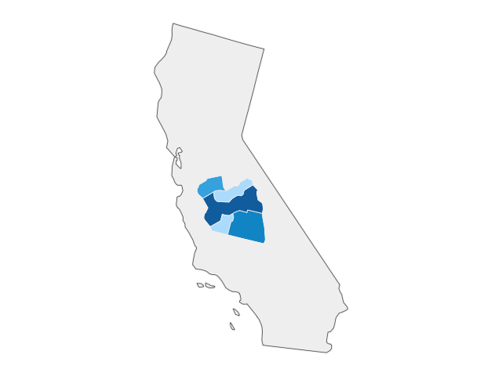

County | 2027 Jobs
Fresno County, CA | 8,831
Tulare County, CA | 3,953
Merced County, CA | 1,871
Madera County, CA | 1,353
Kings County, CA | 925

Job Postings Summary
6,178 | 5 : 1
Unique Postings (Jan 2017 - Feb 2018) | Posting Intensity (Jan 2017 - Feb 2018)
31,246 Total Postings | Regional Average: 7 : 1
There were 31,246 total job postings for your selection from January 2017 to February 2018, of which 6,178 were unique. These numbers give us a Posting Intensity of 5-to-1, meaning that for every 5 postings there is 1 unique job posting.This is lower than the Posting Intensity for all other occupations and companies in the region (7-to-1), indicating that they may not be trying as hard to hire for this position.
Job Postings vs. Hires
441 | 956
Avg. Monthly Postings (Jan 2017 - Feb 2018) | Avg. Monthly Hires (Jan 2017 - Feb 2018)
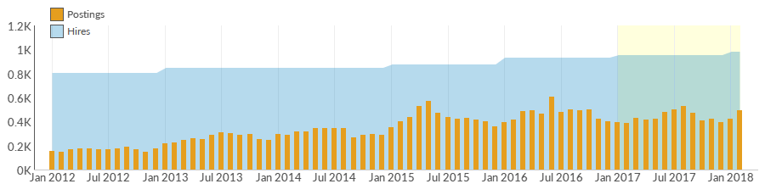
Occupation | Avg Monthly Postings (Jan 2017 - Feb 2018) | Avg Monthly Hires (Jan 2017 - Feb 2018)
Maintenance and Repair Workers, General | 270 | 466
First-Line Supervisors of Mechanics, Installers, and Repairers | 120 | 122
Heating, Air Conditioning, and Refrigeration Mechanics and Installers | 34 | 105
Installation, Maintenance, and Repair Workers, All Other | 7 | 57
Plumbers, Pipefitters, and Steamfitters | 6 | 93
Helpers--Installation, Maintenance, and Repair Workers | 4 | 33
Helpers--Pipelayers, Plumbers, Pipefitters, and Steamfitters | 0 | 10
Maintenance Workers, Machinery | 0 | 70

Occupation Gender Breakdown
 | Gender | 2017 Jobs | 2017 Percent
● | Males | 14,011 | 96.4%
● | Females | 528 | 3.6%
Occupation Age Breakdown
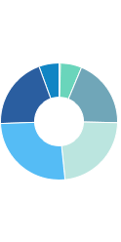
 | Age | 2017 Jobs | 2017 Percent
● | 14-18 | 56 | 0.4%
● | 19-24 | 857 | 5.9%
● | 25-34 | 2,769 | 19.0%
● | 35-44 | 3,348 | 23.0%
● | 45-54 | 3,792 | 26.1%
● | 55-64 | 2,908 | 20.0%
● | 65+ | 808 | 5.6%

Occupation Race/Ethnicity Breakdown
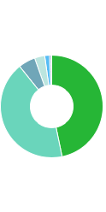
 | Race/Ethnicity |  |  | 2017 Jobs |  |  | 2017 Percent
● | White |  |  | 6,797 |  |  | 46.7%
● | Hispanic or Latino |  |  | 6,178 |  |  | 42.5%
● | Asian |  |  | 776 |  |  | 5.3%
● | Black or African American |  |  | 468 |  |  | 3.2%
● | Two or More Races |  |  | 212 |  |  | 1.5%
● | American Indian or Alaska Native |  |  | 71 |  |  | 0.5%
● | Native Hawaiian or Other Pacific Islander |  |  | 37 |  |  | 0.3%
Occupational Programs
8 |  |  | 569 |  | 1,756
Programs (2016) |  |  | Completions (2016) |  | Openings (2016)
CIP Code |  | Program |  |  |  | Completions (2016)
47.0201 |  | Heating, Air Conditioning, Ventilation and Refrigeration Maintenance Technology/Technician |  |  |  | 332
47.0303 |  | Industrial Mechanics and Maintenance Technology |  |  |  | 133
15.0501 |  | Heating, Ventilation, Air Conditioning and Refrigeration Engineering Technology/Technician |  |  |  | 54
47.0101 |  | Electrical/Electronics Equipment Installation and Repair, General |  |  |  | 50
15.0505 |  | Solar Energy Technology/Technician |  |  |  | 0

Industries Employing 8 Occupations
Industry | Occupation Group Jobs in Industry (2017) | % of Occupation Group in Industry (2017) | % of Total Jobs in Industry (2017)
Plumbing, Heating, and Air-Conditioning Contractors | 2,488 | 17.1% | 48.9%
Local Government, Excluding Education and Hospitals | 1,273 | 8.8% | 3.5%
Elementary and Secondary Schools (Local Government) | 448 | 3.1% | 0.8%
Residential Property Managers | 396 | 2.7% | 20.2%
Crop Production | 340 | 2.3% | 1.0%

Appendix A - Data Sources and Calculations
Location Quotient
Location quotient (LQ) is a way of quantifying how concentrated a particular industry, cluster, occupation, or demographic group is in a region as compared to the nation. It can reveal what makes a particular region unique in comparison to the national average.
Occupation Data
Emsi occupation employment data are based on final Emsi industry data and final Emsi staffing patterns. Wage estimates are based on Occupational Employment Statistics (QCEW and Non-QCEW Employees classes of worker) and the American Community Survey (Self-Employed and Extended Proprietors). Occupational wage estimates also affected by county-level Emsi earnings by industry.
CareerBuilder/Emsi Job Postings
Job postings are collected from various sources and processed/enriched by Careerbuilder to provide information such as standardized company name, occupation, skills, and geography. Emsi performs additional filtering and processing to improve compatibility with Emsi data.
Institution Data
The institution data in this report is taken directly from the national IPEDS database published by the U.S. Department of Education's National Center for Education Statistics.
State Data Sources
This report uses state data from the following agencies: California Labor Market Information Department

