Occupation Overview
Emsi Q4 2018 Data Set
November 2018
California
Parameters
Occupations
Code | Description
11-3011 | Administrative Services Managers
11-9199 | Managers, All Other
41-9099 | Sales and Related Workers, All Other
43-4051 | Customer Service Representatives
43-9061 | Office Clerks, General
43-9199 | Office and Administrative Support Workers, All Other

Regions
Code | Description
6019 | Fresno County, CA
6031 | Kings County, CA
6039 | Madera County, CA
6047 | Merced County, CA
6107 | Tulare County, CA

Timeframe
2018 - 2028
Datarun
2018.4 – QCEW Employees, Non-QCEW Employees, and Self-Employed
6 Occupations in 5 California Counties

Occupation Summary for 6 Occupations
28,995 |  | 8.5% |  | $16.49/hr
Jobs (2018) |  | % Change (2018-2028) |  | Median Hourly Earnings
26% below National average |  | Nation: 6.8% |  | Nation: $16.59/hr
Growth
28,995 | 31,467 |  | 2,472 |  | 8.5%
2018 Jobs | 2028 Jobs |  | Change (2018-2028) |  | % Change (2018-2028)
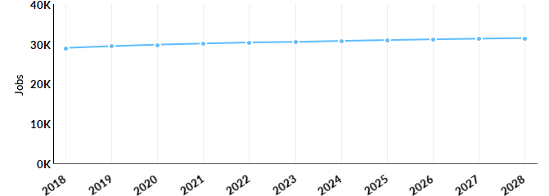
Occupation | 2018 Jobs | 2028 Jobs | Change | % Change
Administrative Services Managers (11-3011) | 1,316 | 1,463 | 147 | 11%
Managers, All Other (11-9199) | 3,124 | 3,484 | 360 | 12%
Sales and Related Workers, All Other (41-9099) | 511 | 555 | 44 | 9%
Customer Service Representatives (43-4051) | 8,117 | 9,003 | 886 | 11%
Office Clerks, General (43-9061) | 14,030 | 14,884 | 854 | 6%
Office and Administrative Support Workers, All Other (43-9199) | 1,897 | 2,078 | 181 | 10%

Percentile Earnings
$12.38/hr | $16.49/hr | $20.88/hr
25th Percentile Earnings | Median Earnings | 75th Percentile Earnings
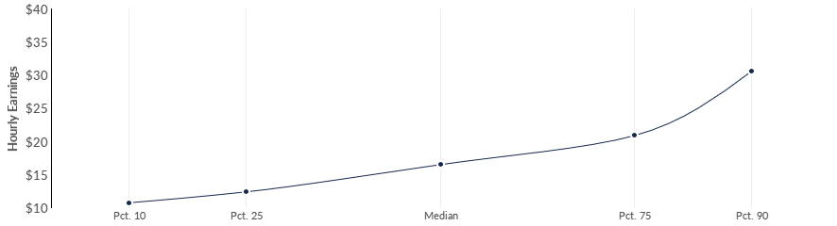
Occupation | 25th Percentile Earnings | Median Earnings | 75th Percentile Earnings
Administrative Services Managers (11-3011) | $31.74 | $41.58 | $54.28
Managers, All Other (11-9199) | $16.69 | $21.59 | $49.82
Sales and Related Workers, All Other (41-9099) | $14.53 | $19.19 | $24.58
Customer Service Representatives (43-4051) | $12.13 | $16.34 | $19.76
Office Clerks, General (43-9061) | $11.80 | $15.46 | $18.76
Office and Administrative Support Workers, All Other (43-9199) | $11.05 | $13.91 | $19.22
Regional Trends
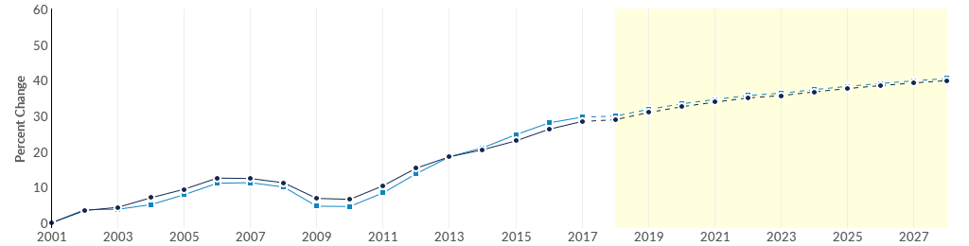
 | Region | 2018 Jobs | 2028 Jobs | Change | % Change
● | Region | 28,995 | 31,467 | 2,472 | 8.5%
● | Fresno, CA | 16,927 | 18,301 | 1,374 | 8.1%

Regional Breakdown
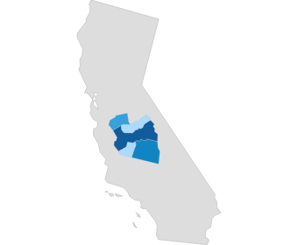
County |  | 2028 Jobs
Fresno County, CA |  | 18,301
Tulare County, CA |  | 5,793
Merced County, CA |  | 3,694
Madera County, CA |  | 1,947
Kings County, CA |  | 1,731
Job Postings Summary
3,680 | 4 : 1 |  | 28 days
Unique Postings | Posting Intensity |  | Median Posting Duration
14,695 Total Postings | Regional Average: 4 : 1 |  | Regional Average: 29 days
There were 14,695 total job postings for your selection from January 2018 to September 2018, of which 3,680 were unique. These numbers give us a Posting Intensity of 4-to-1, meaning that for every 4 postings there is 1 unique job posting.This is close to the Posting Intensity for all other occupations and companies in the region (4-to-1), indicating that they are putting average effort toward hiring for this position.
Job Postings vs. Hires
893 | 1,829
Avg. Monthly Postings (Jan 2018 - Sep 2018) | Avg. Monthly Hires (Jan 2018 - Sep 2018)
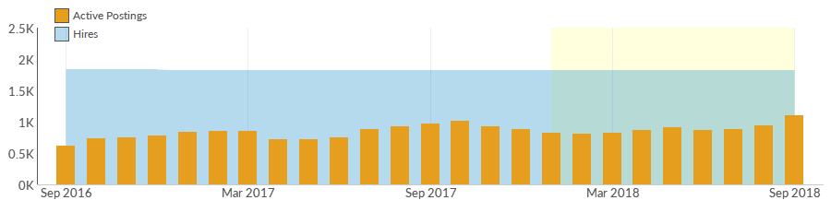
Occupation | Avg Monthly Postings (Jan 2018 - Sep 2018) | Avg Monthly Hires (Jan 2018 - Sep 2018)
Customer Service Representatives | 601 | 523
Managers, All Other | 155 | 84
Office Clerks, General | 100 | 1,049
Administrative Services Managers | 19 | 61
Office and Administrative Support Workers, All Other | 9 | 86
Sales and Related Workers, All Other | 9 | 27
Occupation Gender Breakdown
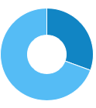
 | Gender | 2018 Jobs | 2018 Percent
● | Males | 8,866 | 30.6%
● | Females | 20,129 | 69.4%

Occupation Age Breakdown
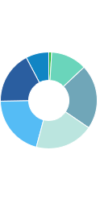
 | Age | 2018 Jobs | 2018 Percent
● | 14-18 | 278 | 1.0%
● | 19-24 | 3,483 | 12.0%
● | 25-34 | 6,258 | 21.6%
● | 35-44 | 5,683 | 19.6%
● | 45-54 | 5,968 | 20.6%
● | 55-64 | 5,086 | 17.5%
● | 65+ | 2,238 | 7.7%
Occupation Race/Ethnicity Breakdown
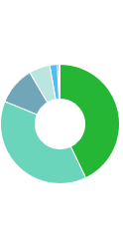
 | Race/Ethnicity |  |  |  | 2018 Jobs |  |  |  | 2018 Percent
● | White |  |  |  | 12,436 |  |  |  | 42.9%
● | Hispanic or Latino |  |  |  | 11,087 |  |  |  | 38.2%
● | Asian |  |  |  | 3,002 |  |  |  | 10.4%
● | Black or African American |  |  |  | 1,656 |  |  |  | 5.7%
● | Two or More Races |  |  |  | 599 |  |  |  | 2.1%
● | American Indian or Alaska Native |  |  |  | 116 |  |  |  | 0.4%
● | Native Hawaiian or Other Pacific Islander |  |  |  | 99 |  |  |  | 0.3%
Occupational Programs
19 |  |  | 2,019 |  |  | 3,377
Programs (2017) |  |  | Completions (2017) |  |  | Openings (2017)
CIP Code |  | Program |  |  |  |  | Completions (2017)
52.0201 |  | Business Administration and Management, General |  |  |  |  | 1,670
52.0408 |  | General Office Occupations and Clerical Services |  |  |  |  | 276
52.0101 |  | Business/Commerce, General |  |  |  |  | 37
44.0401 |  | Public Administration |  |  |  |  | 14
52.9999 |  | Business, Management, Marketing, and Related Support Services, Other |  |  |  |  | 13
Industries Employing 6 Occupations
Industry |  |  |  | Occupation Group Jobs in Industry (2018) |  |  |  | % of Occupation Group in Industry (2018) |  | % of Total Jobs in Industry (2018)
Local Government, Excluding Education and Hospitals |  |  |  | 2,178 |  |  |  | 7.5% |  | 6.0%
Colleges, Universities, and Professional Schools (State Government) |  |  |  | 1,212 |  |  |  | 4.2% |  | 13.9%
Elementary and Secondary Schools (Local Government) |  |  |  | 994 |  |  |  | 3.4% |  | 1.7%
Colleges, Universities, and Professional Schools (Local Government) |  |  |  | 939 |  |  |  | 3.2% |  | 10.8%
State Government, Excluding Education and Hospitals |  |  |  | 719 |  |  |  | 2.5% |  | 4.8%

Appendix A - Data Sources and Calculations
Location Quotient
Location quotient (LQ) is a way of quantifying how concentrated a particular industry, cluster, occupation, or demographic group is in a region as compared to the nation. It can reveal what makes a particular region unique in comparison to the national average.
Occupation Data
Emsi occupation employment data are based on final Emsi industry data and final Emsi staffing patterns. Wage estimates are based on Occupational Employment Statistics (QCEW and Non-QCEW Employees classes of worker) and the American Community Survey (Self-Employed and Extended Proprietors). Occupational wage estimates also affected by county-level Emsi earnings by industry.
Emsi Job Postings
Job postings are collected from various sources and processed/enriched to provide information such as standardized company name, occupation, skills, and geography.
Institution Data
The institution data in this report is taken directly from the national IPEDS database published by the U.S. Department of Education's National Center for Education Statistics.
State Data Sources
This report uses state data from the following agencies: California Labor Market Information Department

